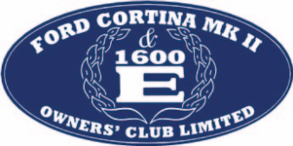

Registered No: 04799639
Registered Office: 51 Elderberry Close, Langdon Hills, Essex. SS16 6RL

APPLICATION TO BECOME A MEMBER OF
THE FORD CORTINA MK 11 & 1600E OWNERS’ CLUB LIMITED
(COMPANY NUMBER 04799639)
(“the Company”)

I hereby apply to become a member of the Company.

If my application is accepted, I hereby agree to: -

- Be bound by the Memorandum and Articles of Association of the Company (as amended from time to time);

- Comply with the obligations to contribute a sum not exceeding £1.00 to the assets of the Company in the event of the Company being wound up in accordance with clause 7 of the Memorandum of Association of the Company.

- Promptly inform the Company Membership Secretary of any change in address or other changes in my particulars.

I wish that you place my name on the Register of Members of the Company.

Name (Please Print)

Address

Signature Date

Please complete and return to the Membership Secretary along with your Application for Membership form

John Alborough


The Old Church, Auchnagatt, Ellon, Aberdeenshire, AB41 8YB. UK
mk2and1600e.membership@gmail.com

